Lab 1 – Setting Up Flutter and Running Your First App
1. Objective
This lab helps students set up the Flutter environment and run their first Flutter application. Students will learn how to install tools, create a project, execute it on a device/emulator, and perform basic UI customization.
2. Requirements
Students must:
- Install Flutter SDK
- Configure IDE (Android Studio or VS Code)
- Create and run a Flutter app
- Customize the layout
- Submit screenshots as evidence
3. Guided Steps
Exercise 1 – Flutter Environment Setup
Goal: Install and verify Flutter tools.
Steps
- Install Flutter SDK.
- Add Flutter to PATH.
- Run:
flutter doctor
- Ensure all items are properly configured.
- Verify Flutter & Dart plugins in Android Studio.
Deliverables
- Screenshot of flutter doctor(Xcode is not used in this semester for iOS and macOS app, so I just ignore it)
- 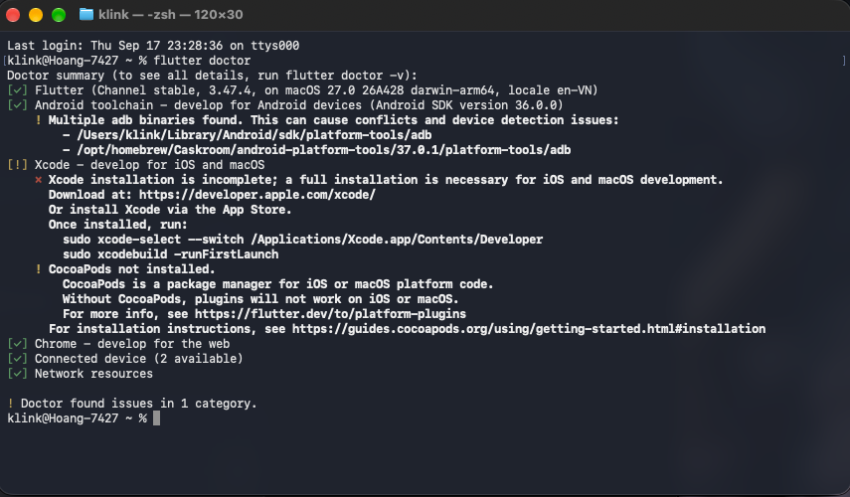
- Screenshot of Flutter/Dart plugin screen
- 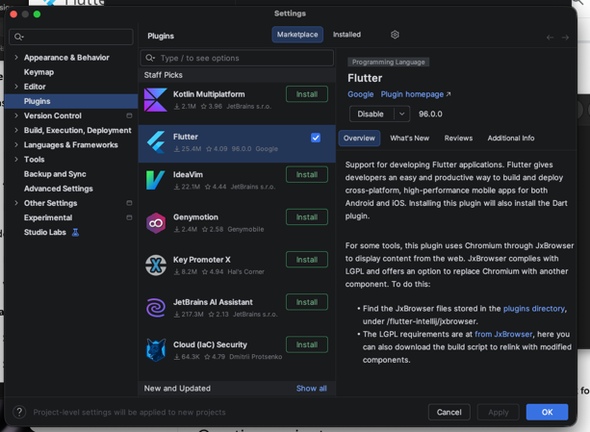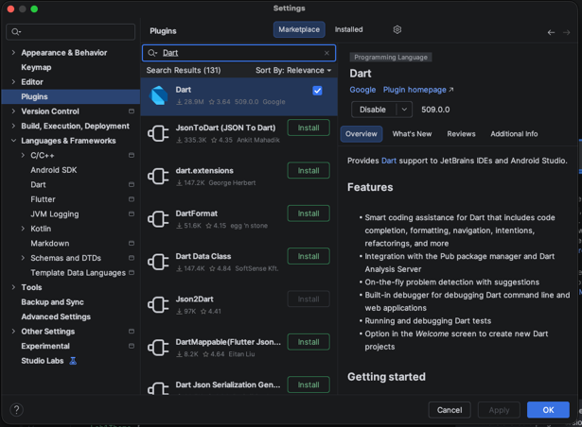

Exercise 2 – Create and Run Your First Flutter App
Goal: Learn how to create a Flutter project and run the default app.
Steps
- Open Android Studio → New Flutter Project
- Use project name: hello_flutter_lab1
- Explore key folders: lib/, android/, ios/, pubspec.yaml
- Start emulator or connect device
- Run the default counter app
- Modify the AppBar title in main.dart:
title: 'My First Flutter App',
- Use Hot Reload and observe changes
Deliverables
- Screenshot of project structure
- 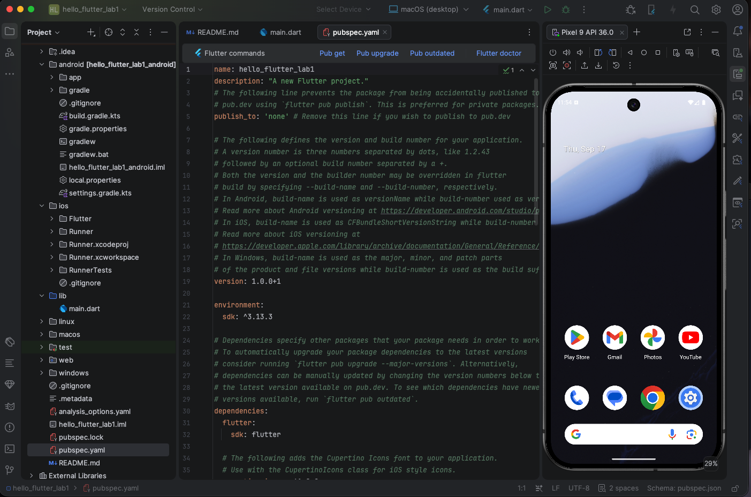
- Screenshot of running counter app
- 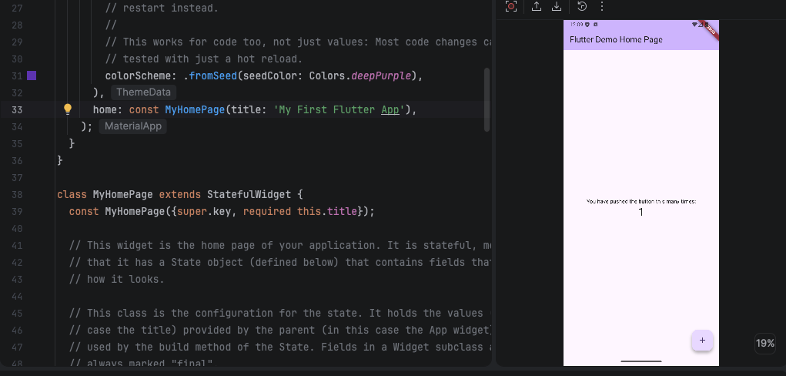
- Screenshot showing updated title via Hot Reload
- 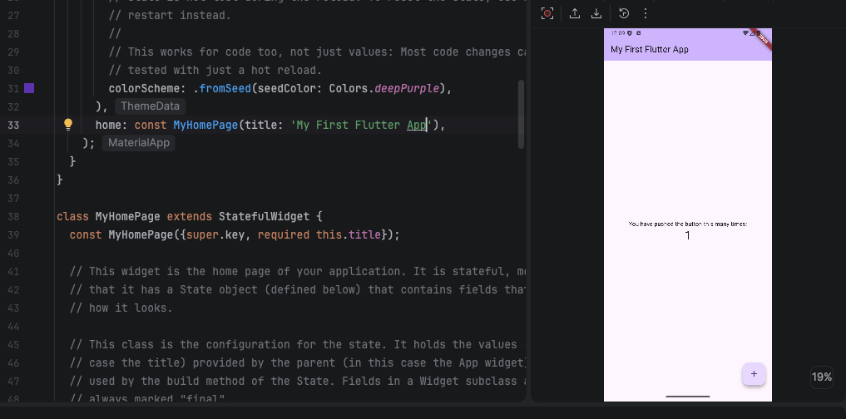

Exercise 3 – Customize Your First Flutter UI
Goal: Build a simple custom UI with widgets learned in class.
Steps
- Replace default code in main.dart with:
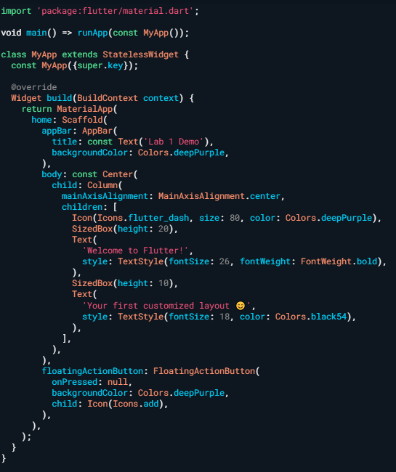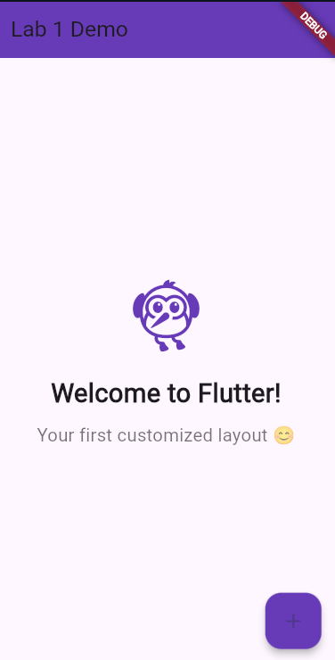
- Perform Hot Reload and verify UI updates.
- Modify colors/text and reload again.
- 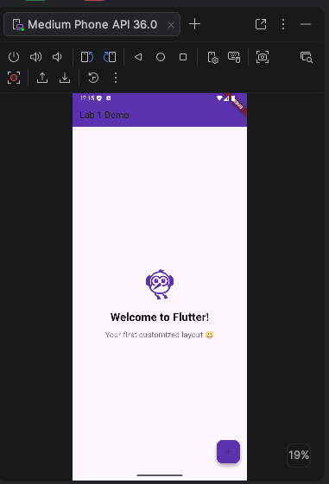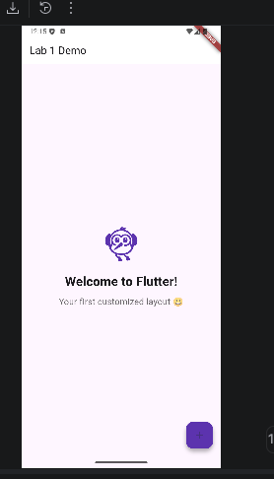
Exercise 4 – Reflection Questions
- What is the purpose of the flutter doctor command?
- This command is used to check for pre-requirement for components to make sure flutter app development run flawlessly
- What file acts as the entry point of a Flutter application?
The lib/main.dart file is the primary entry point of a Flutter application. Execution begins at the main() function within this file.
- Explain the difference between Hot Reload and Hot Restart.
- Hot Reload: Injects updated source code into the running Dart Virtual Machine (VM) and reconstructs the widget tree. It instantly updates the UI while preserving the app's current state (e.g., user input in a text field or the current navigation route remains intact).
- Hot Restart: Completely destroys the preserved state, recompiles the application code, and restarts the Dart VM. It is necessary when making structural changes like modifying global variables, adding new assets, or changing the app's entry point.
- How does runApp() build the widget tree?
The runApp() function takes a given widget and attaches it to the screen, designating it as the root of the widget tree. Once the root is set, Flutter traverses the tree, invoking the build() methods of the provided widget and its children. It inflates these widgets into a corresponding Element tree (which manages the lifecycle and state) and a RenderObject tree (which handles the actual mathematical layout and painting on the screen).
- Describe how Flutter’s architecture enables cross-platform development.
Flutter achieves cross-platform consistency by bypassing native platform UI components (OEM widgets). Instead of bridging Dart code to native iOS or Android buttons, Flutter requests a blank canvas from the host operating system. It then uses its own high-performance C/C++ graphics engine (Skia or Impeller) to draw every pixel of the UI directly. Additionally, Flutter compiles Dart code Ahead-of-Time (AOT) into native ARM or x86 machine code for mobile and desktop, ensuring native execution speeds across all platforms from a single codebase.
4. Expected Results
- Successful setup of Flutter environment
- Ability to create and run Flutter projects
- Understanding of widgets, layout, and hot reload
- Complete screenshots for all required steps

5. Submission
- Zipped Flutter project folder or GitHub link
- All screenshots
- Written answers for reflection questions

